Groww is a direct-to-customer digital investment platform that provides wealth creation opportunities to customers through multiple financial products and services.

How Groww makes money:

- Key business lines:
    - Broking (derivatives and stocks); revenue is max (fee per order, % of volume traded)
    - Margin Trading Facility and Loans (personal loans, Loans against securities) : revenue is interest income.
    - Wealth management and AMC (very small): a mix of fee per user of % of AUM managed
    - Float income on user cash assets on platform

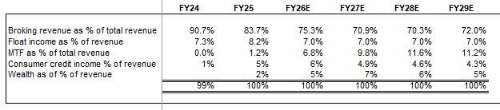
Some Stats:

  - By active user count, Groww is a market leader in brokerage by a wide margin (market share of active users for Groww at 26%, with #2 at 16%) and it continues to gain market share. (TTM June 2025, Groww accounted for 45% of industry-wide user addition)
  - Groww has unmatched geographic reach with users from almost 99% of pin codes in India, and 82% of active users are beyond top 6 cities in India. Young Customer Base: ~45% of Active Users were less than 30 years old as of June 30, 2025. The median age of active users was ~31 years as of June 30, 2025.
  - Retention: Across cohorts of active users who completed three years on the platform, the average retention was 78%.
  - Organic Acquisition: 83% of new customers were acquired organically in the three months ended June 30, 2025.
  - Brokerage penetration is low in India, indicating room for growth for players like Groww; only around ~5% penetration for active broking accounts in CY2024 (compared to ~60% in US). Brokerages in India are quickly moving digital with digital-first platforms accounting for 76 - 78% of active clients on the NSE in FY2025 (up from 38 - 40% in FY2020).
  - Groww’s technology and product team is one of the best in India. Through product and content led growth (83% of new customers acquired organically), Groww has managed to scale the platform to 100 million downloads, with 14m + monthly active users, displaying one of industry’s best benchmarks in terms of MAUs/DAUs of 55%+.

Why does the opportunity to make 25%+ IRR exist? ( Variant Perception)

Regulatory: Given excess FnO activity in the Indian markets, SEBI, the Indian regulator has passed regulations to reduce derivatives trading activity. More are expected to be announced in December 2025.
Since about 60% of Groww’s current revenues come from derivatives trading, this uncertainty is weighing down on valuation. O8’s assessment of impact on revenue related to derivatives is ~20%-25% YoY and the company has already seen this impact the past 2 quarters; Read through from results of other online brokerages (Angel One) indicates a similar number as well.
Market is worried about this risk and hence brokerage stocks in India, specially those that have higher exposure to revenues from derivatives have been very volatile over the past year – multiples currently on an upswing as the worst is believed to be over.

Brokerages as cyclical and competitive businesses: Market believes that brokerage businesses are cyclical, have low barriers to entry/ highly competitive and hence these stocks trade at low multiples relatively speaking. For example, though less than a decade old, Groww has emerged as #1 broker in India and get to market share of 26% ostensibly, given the lack of entry barriers. Multiples likely lower also in the context of limited revenue opportunities for discount brokers in India, unlike a Charles Schwab, RobinHood etc that can monetize float or data (payment for order flow).

We expect some volatility and hence opportunity to trade: Similar to O8’s experience with Adyen, Robinhood, etc we believe that as Groww might hit air pockets in its initial year of trading as a public company, and we can work with the CEO and IR of the company to help them articulate their vision succinctly, guide consistently and help Groww achieve a multiple commensurate with its superior product led growth profile.

We believe Groww can compound revenue and earnings at 25%+ CAGR over the next 5+ years/ for a long time given the strong tailwind of financialization of household savings which is in its early innings in India. Groww has newer business lines that can drive growth and surprise market on the upside (example: commodities trading which was newly launched)

KPIs:

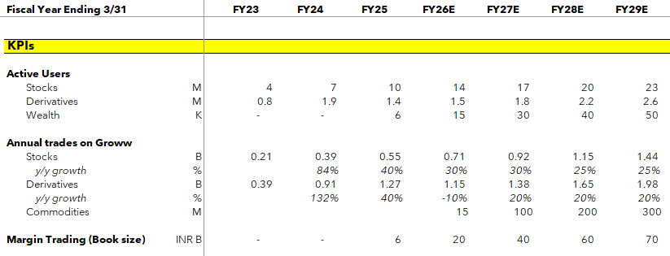

Financials:

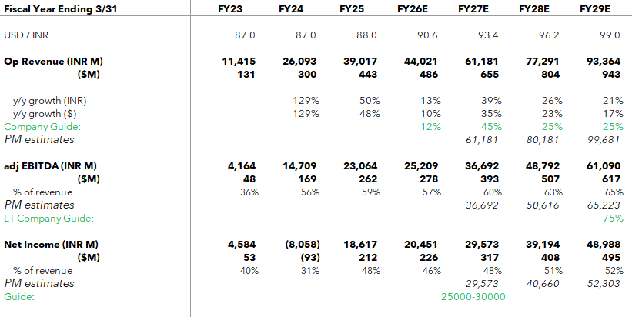
Valuation:
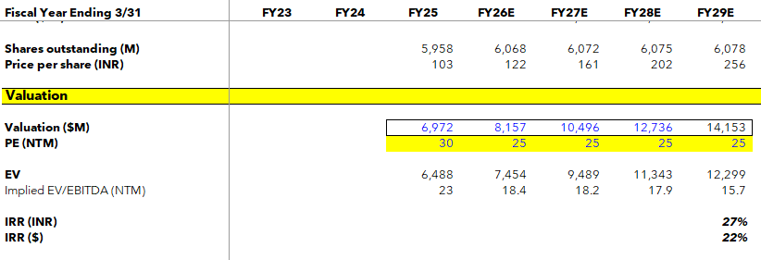

Multiples

